Reporting - How to create an Open interaction report

- To run a timeline report, select administration and then select reports.

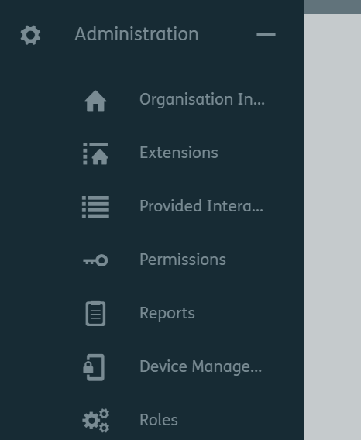
2. Select Reports
- Select Administration

3. Click on the + to create a new report

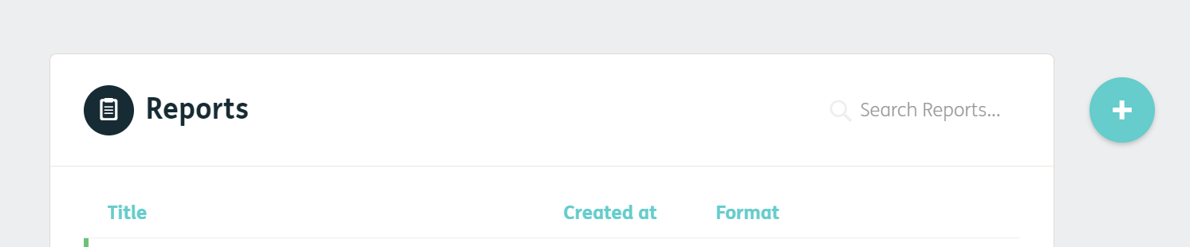

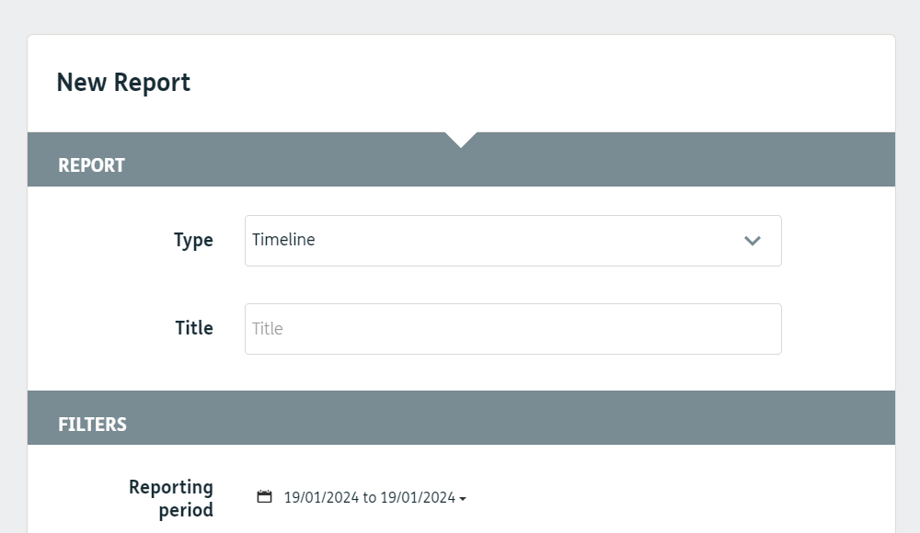
5. Select a date range.
This should be in the past.
4. Give it a title.
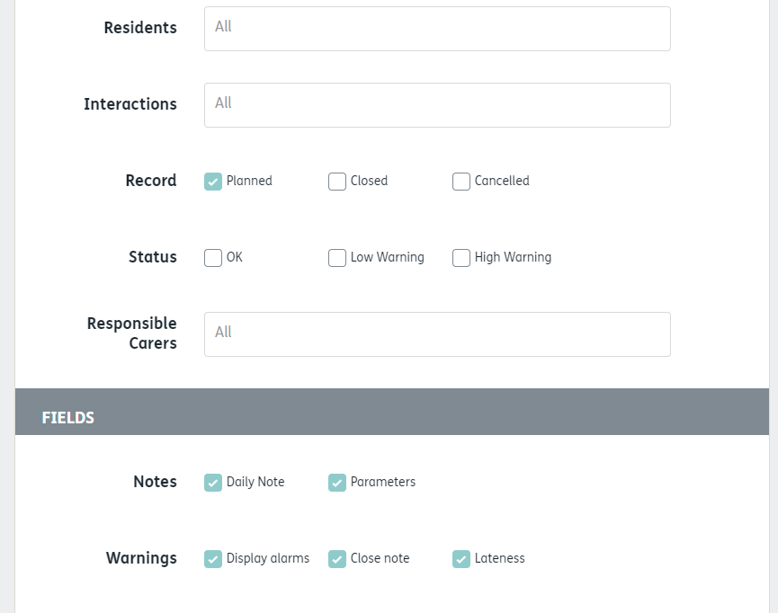
8. Tick planned and untick all other options.
7. Leave as All interactions
6. Leave as All residents
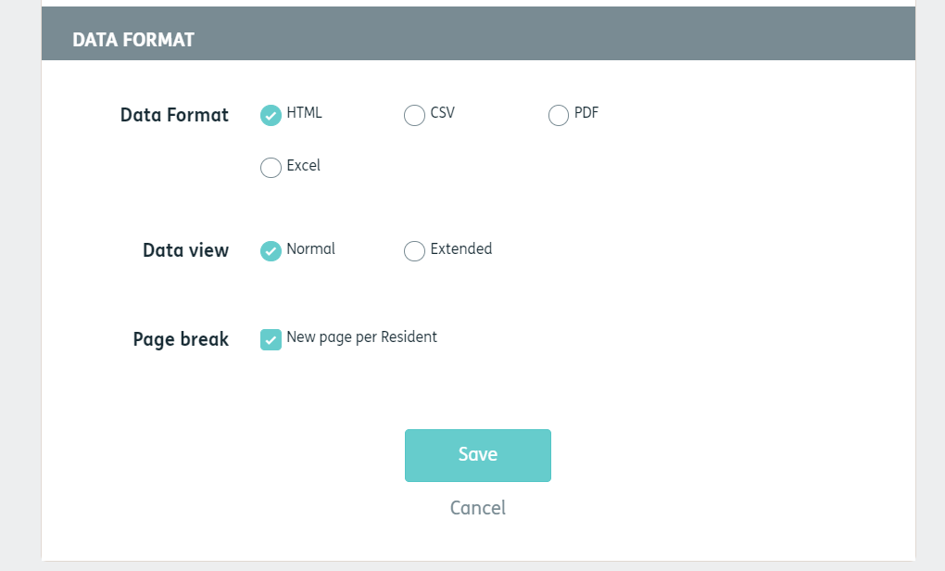
10. Click on save
9. Select format

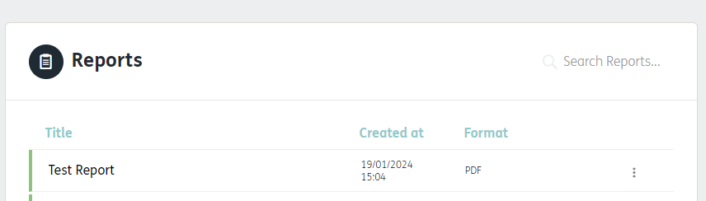
11. Click on the name of the report to open.

